

Individual Project ENGD3000

Project Specification:

Internet of Things restaurant waiting system

***Module tutor: Dr Seng Chong***

***Student – Samuel Towner P Number – P2448117***

### Interim report

Each Student is required to submit an interim progress report of about 1000 words before the end of Term 1. The interim report will ***contribute 15%*** to the overall mark for the project.

The aim of the interim report is to have a clear, succinct overview of the project thus far – including background, plans and progress made since commencement; all of which should be in a proper report format. Consequently, below is a suggested structure that could be followed:

###### *Structure*

* + - Abstract - https://www.projecttopics.org/write-abstract-final-year-project.html
    - Introduction
    - Overall aim and objectives
    - Background/Literature research
    - Progress thus far – give a sketch of the system
    - Plan for the next stage of the project with work breakdown structure and a Gantt chart.
    - Conclusions
    - References

You should aim for a total word count of about 1000 words in the main body. You can use appendices to further report your actual work/progress as appropriate.

###### *Submission*

Please ensure you give a draft to your respective supervisor in good time so that they can give you meaningful feedback in a reasonable time frame. You are required to submit an electronic copy via Turnitin on the Blackboard through the e-submission process (see Section 6.2.3: A guide to electronic submission via Turnitin on the Blackboard).

Suggestion

* + - Background/Literature research
    - Robot waiter – taking orders?
    - A flow chart of

Give a sketch of the overall system

RC mobile robot

Speech recognition with R Pie

Customer order – translated to order – allow some customisation

Kitchen staff prepare food – load and send to customer

Identify the key challenges –

Carry out risk assessment

**Brief description:**

The project will be a collection of products that are internet of things enabled and can communicate between each other to allow faster ordering and a more direct pipeline to the kitchen. This will be done using a main hub - used by employees and chefs, an order taking product situated on each table – used by the customer and a robot capable of transporting the food from the kitchen/loading bay to the table.

# Project aim:

To design and develop…”system”

To utilize IoT enabled products to minimize contact between restaurant staff with customers while also increasing the speed in which an order can get to the kitchen.

# Objectives:

1. Carry out literature review…
2. Develop a product capable of using voice recognition to take an order directly from the customer and send it over an IoT network.
3. Develop a robot capable of mapping and maneuvering around the restaurant while transporting food. - https://www.coppeliarobotics.com/
4. Develop a product capable of showing the kitchen incoming orders.
5. Have all these project components work together/communicate over IoT.

# Brief plan of how to achieve these objectives:

1. Order taking product
   1. Get voice recognition working on either a Raspberry Pi or microcontroller.

<https://cloud.google.com/speech-to-text/pricing>

Customers can be fuzzy

* 1. Create some software that can send a text version of the spoken order along with the table number and any other relevant information over an IoT network.

1. Food delivery robot
   1. Get a basic understanding of ROS.
   2. Prototype a drive setup that’s able to interface with ROS.
   3. Get mapping and spatial checkpoints working with ROS so the robot can move between predetermined points.
   4. Design a system to stabilize the food delivery tray against vibrations.
   5. Get the robot to move to the determined table that is given to it via the IoT network.
2. Kitchen display
   1. Create a system able to receive the sent-out order with the relevant information over the IoT network.
   2. Make a graphical display for this information for the chefs/employees to interact with.

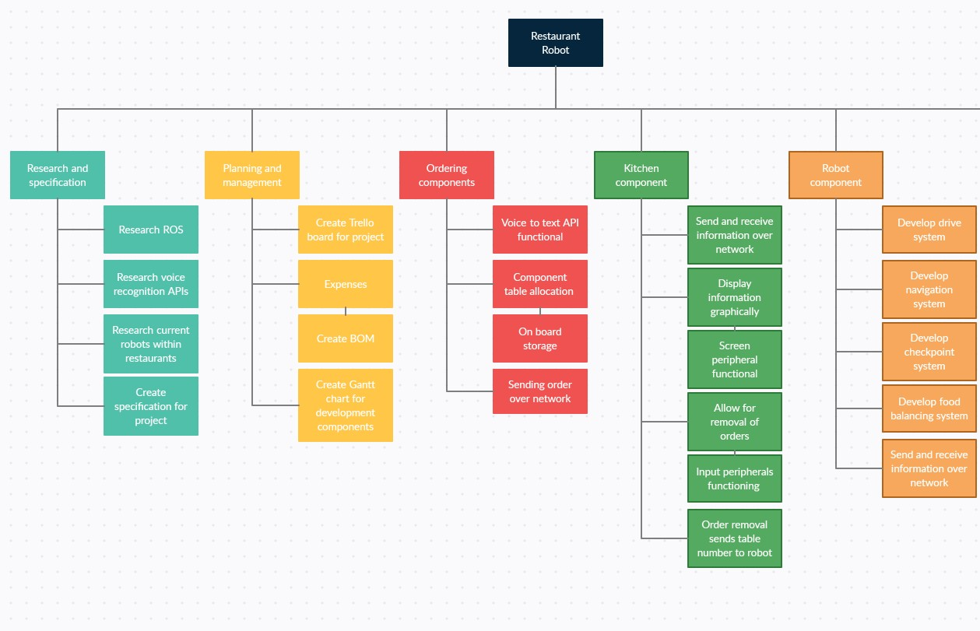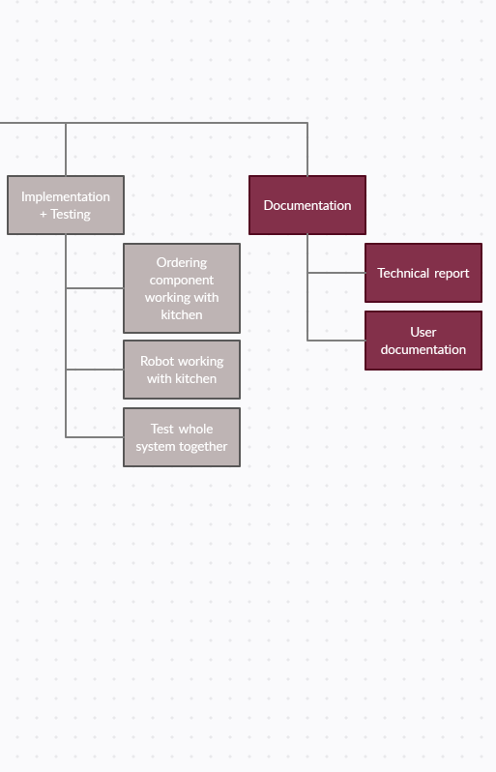

# Work package breakdown: